

**PROJECT ARRANGEMENTS**

**Project proposal**

|  |  |
| --- | --- |
| Students name: | Abulov Ilyas, Ermekov Bolatbek |
| Group name: | CS-2215 |
| Teacher name: | Alshynov Shynggys |
| Project name: | FRIENDSPACE |
| Project type: | Social Network |

*Introduction:*

Social network has become an integral part of our lives. It is used for a variety of purposes, including staying connected with friends and family, sharing information and ideas, and building businesses.

Social network is a powerful tool for staying connected with friends and family. It allows us to stay in touch with people who live far away, and it can help us to build stronger relationships with those who are close to us. Social media can also be used to organize events and gatherings, and it can help us to stay up to date on the latest news and information about our loved ones.

Social network is also a great way to share information and ideas. We can use social media to share our thoughts, opinions, and experiences with others. We can also use social media to learn about new things and to connect with people who share our interests. Social media can be a great way to educate ourselves and to be part of a community.

Finally, social network can be used to build businesses. Businesses can use social media to reach a wider audience, to promote their products and services, and to build relationships with customers. Social media can be a great way to grow a business and to connect with potential customers.

*Project purpose and relevance:*

The main goal of our project is to create a domestic social networking system. As a basis, we took such giants as Facebook and Twitter.

It is impossible to deny the relevance of social networks, as they have recently gained enormous popularity. Everyday millions of people use their services: some are looking for friends, clients, employers, others are just wasting their time.

Social networks allow people to stay in touch. You can fully communicate with your friend, exchange information, share news, interests, experience, while being in different cities or countries. Social networks make it possible to make new acquaintances, find people with the same interests.

Social networks help a person to increase self-esteem. The virtual environment changes a person's consciousness and thinking, multiplies his confidence. Thanks to the positive reviews of other people on the social network page, the mood improves and self-esteem increases.

*Functions of our projec*t:

**Database**: SQLAlchemy is used, providing an Object-Relational Mapping (ORM) to interact with the database. Models are created for users (**Users**) and their posts (**Posts**).

**WTForms for Forms**: Used to handle forms on web pages. Forms include the login form (**LoginForm**), user form (**UserForm**), post form (**PostForm**), search form (SearchForm), forgot password form (ForgotForm), reset password form (ResetPasswordForm), among others.

**Flask-Login**: Manages user authentication, implementing login (**login_user**) and logout (**logout_user**) functions, as well as protecting routes that require authentication (**@login_required**).

**File System**: Used for uploading and storing user profile images (**profile_pic**).

**Flash Messages**: Used to display success or error messages.

**UUID**: Used to generate unique identifiers.

**Werkzeug**: For secure file saving and password hashing.

Additionally, the application includes the following functionalities:

User login (**/login**), **logout** (**/logout**), and authentication.

Pages for adding (**/add-post**), viewing, editing, and deleting posts.

Pages for managing users **(/user/add, /delete/<int:id>, /update/<int:id>, /profile**).

Searching for posts **(/search**).

Overall, the application encompasses user management functionalities, their posts, and provides a basic authentication system, allowing users to create, view, edit, and delete posts, as well as manage their profiles.

*About API service:*

This code complements the previous Flask application with the API service, adding functionality for content moderation specifically designed for administrators. It is designed to filter and remove profanity from user content on a social network.

The Flask-RESTx extension is used to create an API service that provides endpoints for managing publications and users in the application. API endpoints are protected and accessible only to administrators.

*Key Additions:*

API Service: Uses Flask-RESTx to create the ContentGuard API. Authentication and Authorization: Implements basic HTTP authentication to verify administrators. Token-based authentication: Enables token-based session logout (token_required) API.

Endpoints: Offers endpoints for managing posts and users, including functions such as creating, updating, retrieving, and deleting posts and users.

Filtering profanity: The API service is designed to moderate content, allowing only administrators to access publications and users and perform actions with them.

The API documentation describes the purpose of the service, emphasizing its role in providing a respectful online environment by moderating and clearing text input. It describes in detail the endpoints available for managing posts and users, and highlights the API's ability to filter out offensive expressions from the social network.

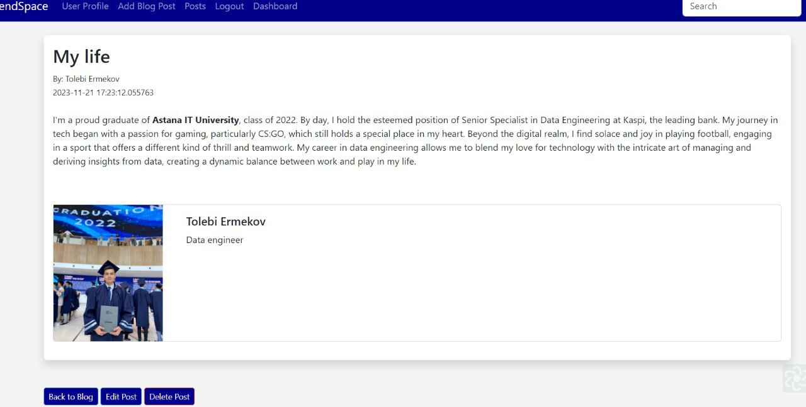

*Picture 1. Creating and sharing of posts*

Posts on social networks can be different in format and content. They can be text, graphic. Posts can also be simple or complex, short or long. Social media posts can be an effective tool for achieving various goals. It is important to create interesting and attractive posts that will be interesting to your audience.

*Picture 2. Dashboard with all your information*

A social media dashboard is a tool that allows you to track and analyze your social media metrics. It can help you understand how your audience is interacting with your content and how you can improve your social media strategy. Social media dashboards can be useful for anyone who uses social media for business or personal use. They can help you improve the effectiveness of your social media efforts and achieve your goals.

In the future we will develop the functionality of our project.

*Project auditory:*

The target audience of social networks includes diverse groups of users who may be interested in the content that is provided on social media platforms. These groups can be determined based on various factors such as age, gender, interests, behavior, etc. Here are some of the main segments of the target audience of social networks:

* Youth and Teenagers: These are active users of social networks who communicate with friends, publish their thoughts and photos, follow trends and develop their interests.
* Young Adults: Between the ages of 18 and 35, they use social networks to communicate, find entertainment, get information and share experiences.
* Professionals and Entrepreneurs: Business people and specialists use social networks for professional networking, job search, exchange of experience and promotion of their brands.
* Older Users: With age, more and more people use social networks to keep in touch with friends and family, receive news and entertainment.
* Parents and Families: This group is looking for information about parenting, family activities, health, etc.
* Fashion and Beauty Lovers: People interested in fashion, beauty, lifestyle, who are looking for inspiration, advice and new trends.
* Travelers and Tour Operators: People planning trips, looking for information about places, reviews, tips and photos.
* Connoisseurs of Art and Culture: People interested in art, music, literature, cinema, who are looking for information about events and novelties in the world of culture.
* Activists and Politicians: People interested in social and political issues, as well as activists who use social networks to organize and support campaigns.
* Sports Enthusiasts: People who are passionate about sports, who follow sports events, exchange experiences and opinions.

***github repository***: https://github.com/Bolatbekermekov/flask_FriendSpace.git